EMPLOYEE MANAGEMENT SYSTEM FOR A SUPERMARKET
PROJECT REPORT

EXECUTIVE SUMMARY
- The Employee Management System for a Supermarket is a database-based system developed to improve the management of employee information and daily operations. The system is designed to replace manual record-keeping methods, which are often slow, inaccurate, and difficult to maintain.
- The project focuses on managing important employee data such as personal details, job roles, attendance records, salary information, and work shifts. By storing this information in a centralized database, the supermarket can easily access, update, and monitor employee records.
- The system uses structured database tables including Employee, Role, Attendance, Shift, and Employee_Shift to organize data efficiently and maintain relationships between records. SQL is used to create, store, retrieve, and analyze the data, while relational algebra operations help demonstrate how information can be queried and processed.
- The main benefit of the system is improved efficiency, accuracy, and security in employee management. It reduces paperwork, minimizes errors, improves attendance tracking, and supports better decision-making by management.

THE BUSINESS CASE
- Problem:
Many supermarkets manage employee records manually using books, files, or spreadsheets. This causes delays, errors, data loss, and difficulty in tracking attendance, salaries, and employee roles. The Employee Management System solves these challenges by providing a centralized database.

- Proposed Solution:
To design an Employee Management System which is a database-based system to help supermarkets manage employee information efficiently by replacing manual record-keeping methods with a computerized system for better storage, retrieval, and management of employee data.
- Objectives of the System
- To store employee records digitally.
- To track attendance of employees.
- To manage employee roles and salaries.
- To assign work shifts.
- To improve efficiency in employee management.
- To reduce paperwork and save time.

4. Scope of the System
The system covers:
- Employee registration
- Attendance management
- Role assignment
- Shift scheduling
- Salary and payroll management

- Resources Required:
- Computer system
- Database software (e.g. MySQL)
- Programming tools (e.g. Visual Studio Code or NetBeans)
- Internet connection
6. Benefits of the System;
- Tangible Benefits
- Faster employee record management.
- Reduced paper work costs.
- Accurate salary calculation.
- Improved attendance tracking.
- Intangible Benefits
    - Better decision making by management.
    - Increased employee accountability.
    - Improved data organization.
    - Enhanced data security.
    - Time saving.
    - Improved data accuracy and validity.

7. System Limitations
- Requires computers and electricity.
- Requires user training.
- Needs maintenance.
- Maynot work well without internet which is costly.

8. System Costs Analysis
- Tangible Costs
    - System development costs.
    - Hardware costs such as computers, servers.
    - Maintenance costs.
- Intangible Costs
- Training employees to use the system.
- Time wasted adopting to the new system.

9. User Related Issues
- Some employees may lack technical knowledge of the system.
- Some employees may resist to change from manual to digital system.
- Training may be required and some may protest it.
- Slow adoption to the system.
Users with access
- Supermarket manager
- HR
- Administration staff
- Employees(Limited access)

10. Risk Assessment
- System failure or bugs
- Data loss if not backed up
- Employees resisting the system
- Poor system usage
- Security threats

THE LOGICAL DESIGN

11. Database Tables and their Attributes
Employee Table | Role Table | Attendance Table | Shift Table | EmployeeShift Table
EmployeeID(PK) | RoleID(PK) | AttendanceID(PK) | ShiftID(PK) | ID(PK)
FirstName | RoleName | EmployeeID(FK) | ShiftName | EmployeeID(FK)
LastName | Salary | Date | StartTime | ShiftID(FK)
Gender |  | Status | EndTime
Phone
Address
DateOfHire
RoleID(FK)

12. ER Diagram and Description of the System
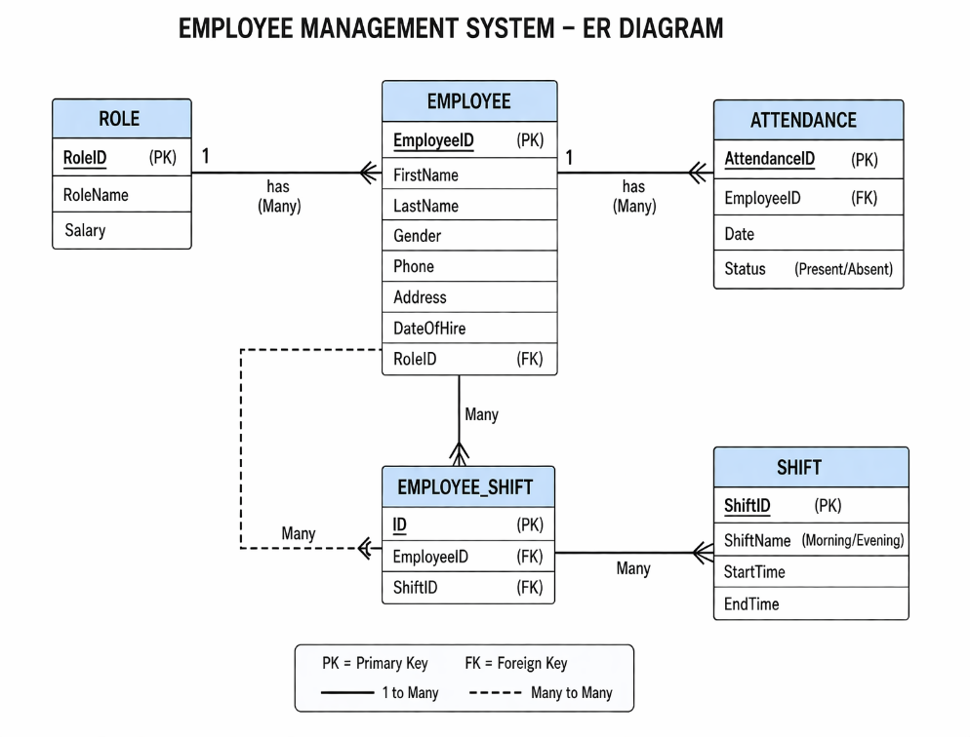
The system consists of five main entities: Employee, Role, Attendance, Shift, and EmployeeShift.
One role can be assigned to many employees. One employee can have many attendance records. Employees can work in many shifts through the EmployeeShift table.

13. Relational Algebra Operations Used in the System
- Selection
σ Status='Present' (Attendance)
- Projection
π FirstName, LastName (Employee)
- Join
Employee ⨝ Role
- Set Difference
π EmployeeID(Employee) − π EmployeeID(σ Status='Present'(Attendance))
- Aggregate
γ COUNT(EmployeeID) (Employee) γ SUM(Salary) (Employee ⨝ Role)

14. Some SQL Queries Implemented
SELECT * FROM Attendance WHERE Status='Present';
SELECT FirstName, LastName FROM Employee;
SELECT FirstName, LastName, RoleName
FROM Employee
JOIN Role ON Employee.RoleID = Role.RoleID;
SELECT SUM(Salary) AS TotalSalary
FROM Employee
JOIN Role ON Employee.RoleID = Role.RoleID;

THE PHYSICAL DESIGN
Database Selection
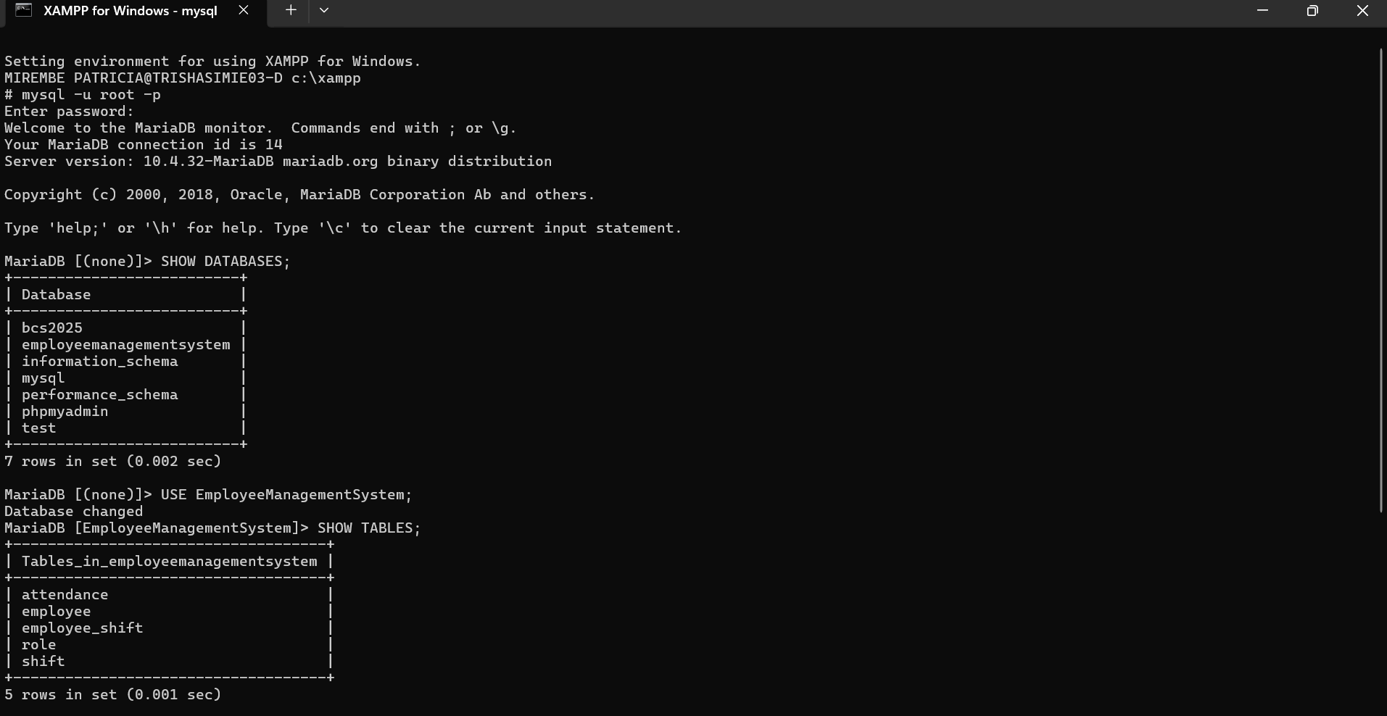

Table Queries
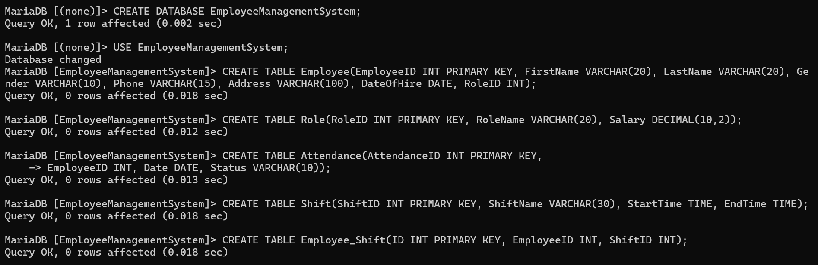

Tables Results
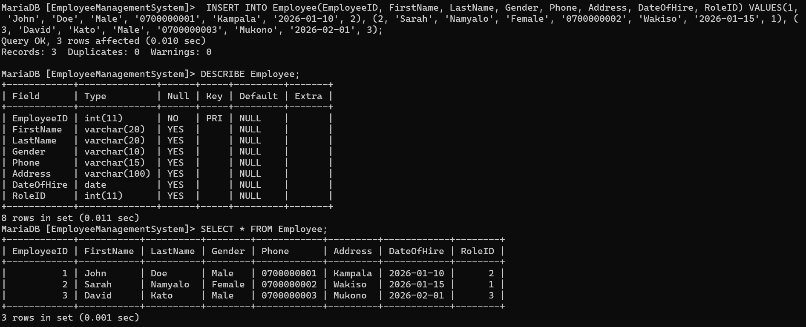

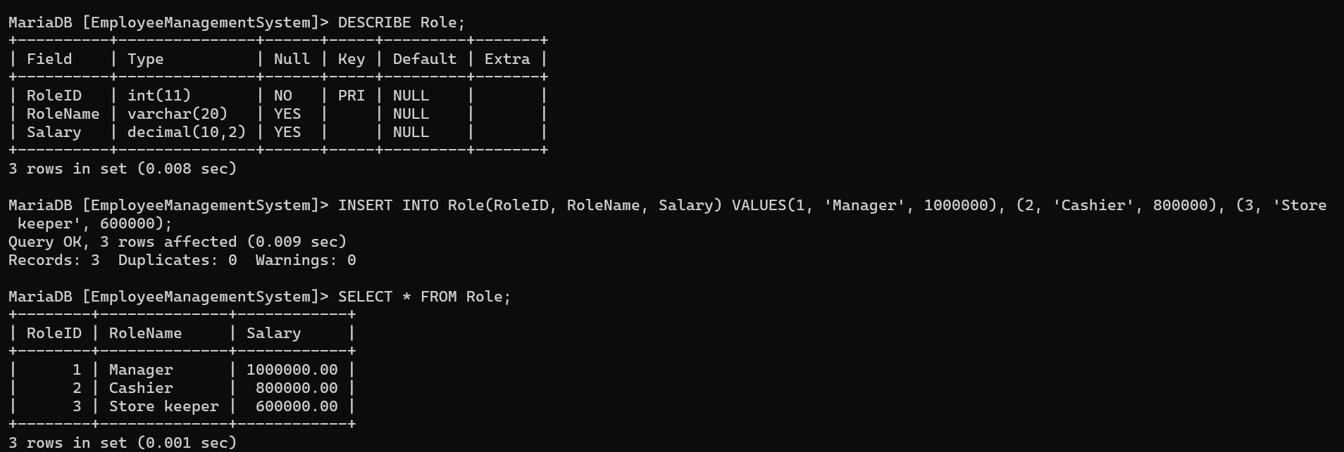

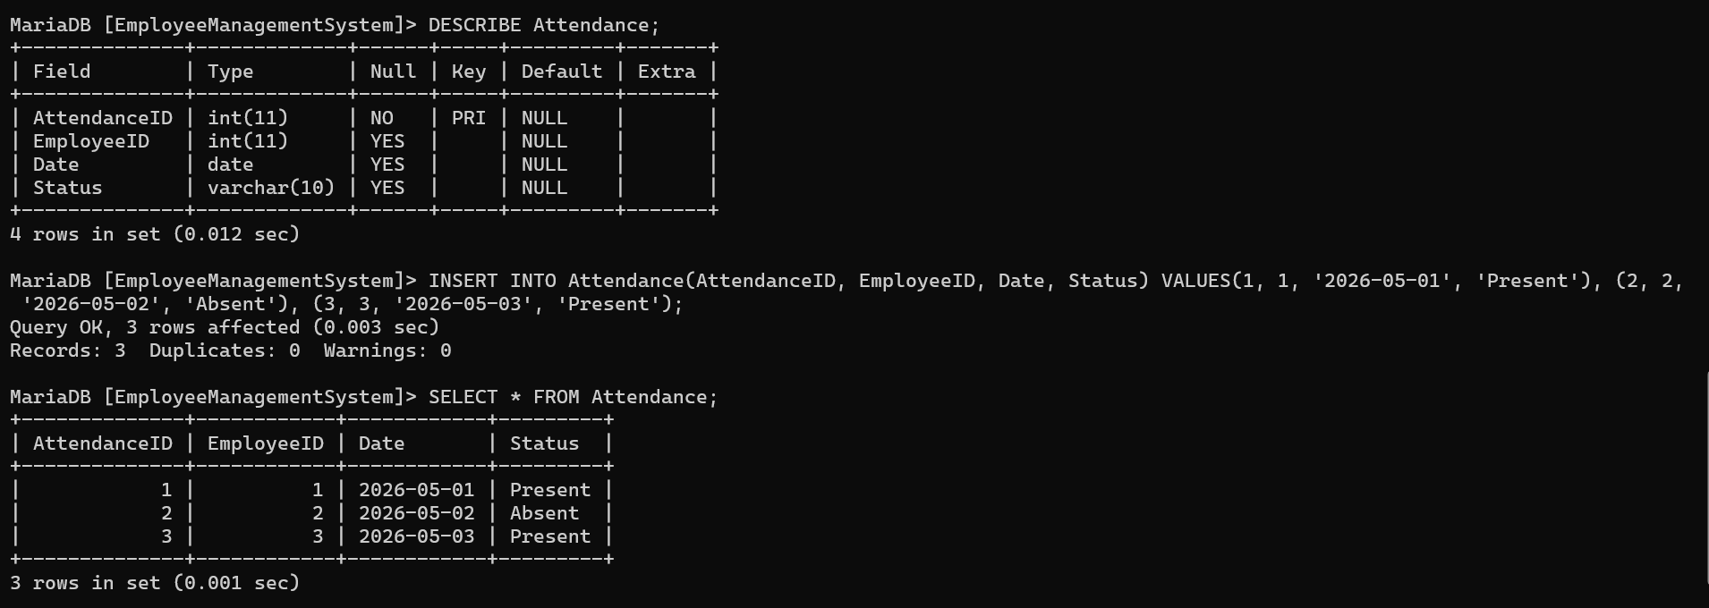

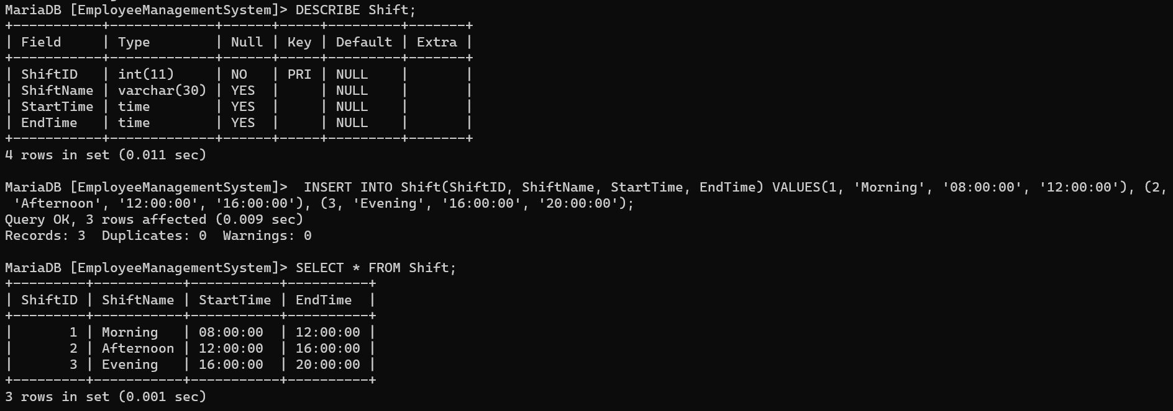

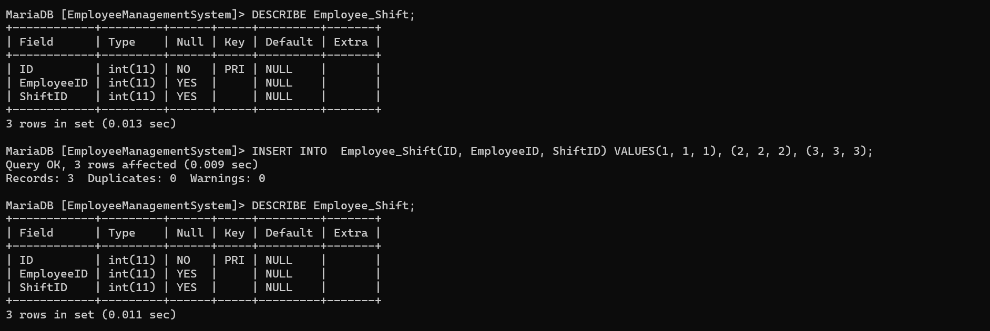

15. Conclusion
The Employee Management System improves the management of employees in supermarkets by making processes faster, more accurate, and more secure and it is a very useful system for modern supermarket operations.

